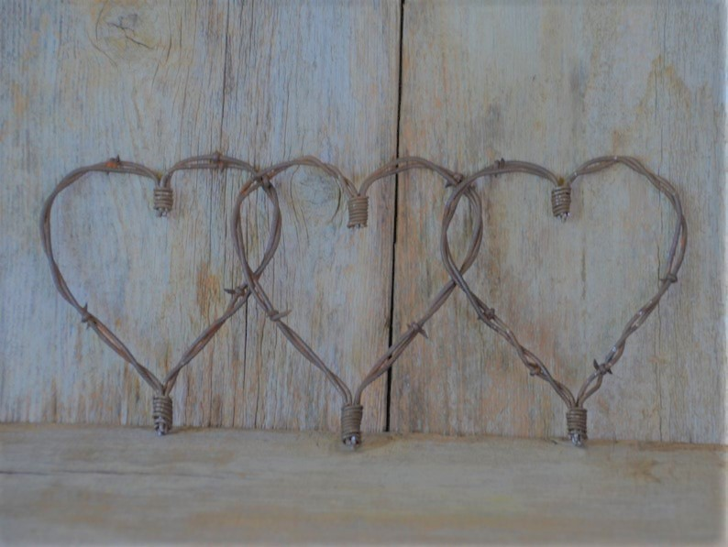

**Live & Silent Auctions**

**Dinner,Drinks & Dancing**

**Live Music by**

**April N Smith**

**& The Company**



**Annual Gala**

**February 4th, 2023**

**The Cascades of Texas – Tyler**

**Doors Open at 6:00 pm**

**Ticket Info: Reserved Table $1000 for 10 guests**

**$125 Singles available**

**Join us and support Smith Co. Youth Scholarships (501c3)**